Dear Parent/Carer,

Access to the Essential Letters and Sounds eBook Library at home

At school, your child is learning to read with Essential Letters and Sounds, a very successful phonics programme published by Oxford University Press.
We will be using an online eBook library to set your child reading practice to do at home each week.
Your child will be given a username and a password so that they can access their own personal student area on OxfordOwl.co.uk. Once they have logged in, your child can complete their homework by going to the homework tab:

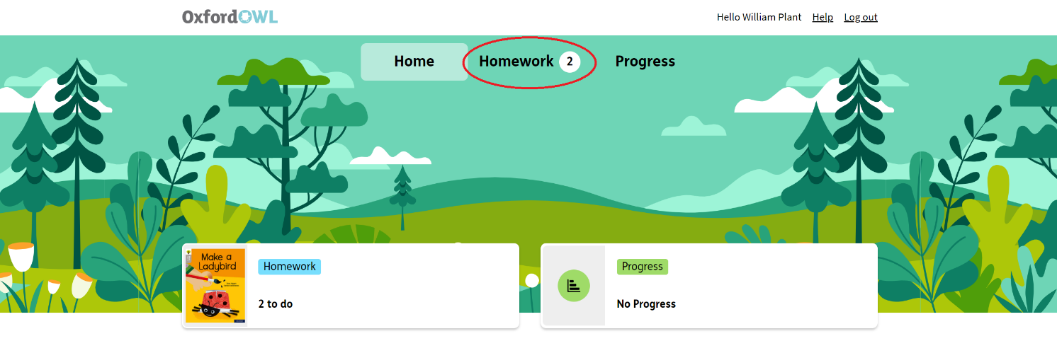

In the homework area, your child will find an eBook which has been assigned to them to read. We suggest that your child reads this text a number of times across the week. Spending 10 minutes a day reading with your child will hugely support them in their journey to becoming an independent reader. It is a key part of learning to read that children re-read words and sentences that they can decode (sound out) until they are fluent (read with ease and precision). By reading texts several times, children have the greatest opportunity to achieve this fluency.
The texts sent home by your child’s school are carefully matched to the teaching taking place. Your child will be practising what they have been taught in school with you at home. Your child should be able to decode and read their phonics book independently, though they may need some support with blending at the beginning of their reading journey. There will be some words that are not decodable, we call these ‘harder to read and spell’, you can help your child with these words when they are reading.

When your child has read the set eBook, they can let their teacher know that they have completed it, and what they thought of it. Ask your child to only click the button to say they have finished when they have read the book a number of times throughout the week.
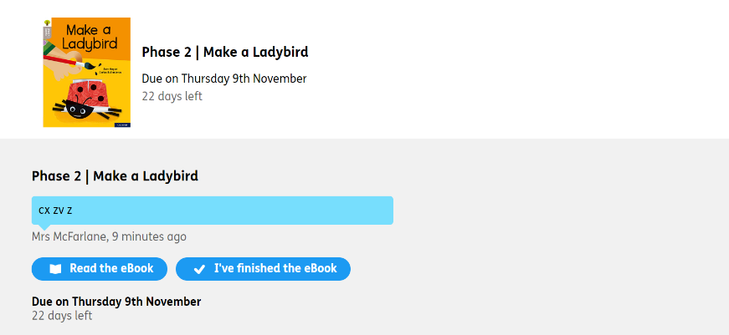

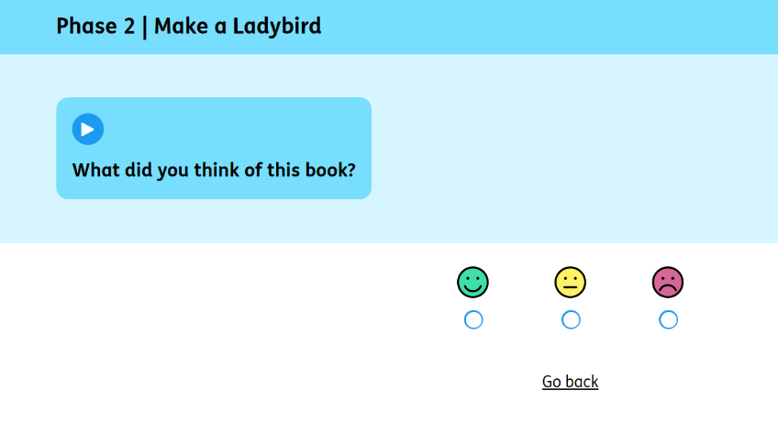
Your child can re-read any of their previous eBooks at any time by clicking on the ELS eBook Library:
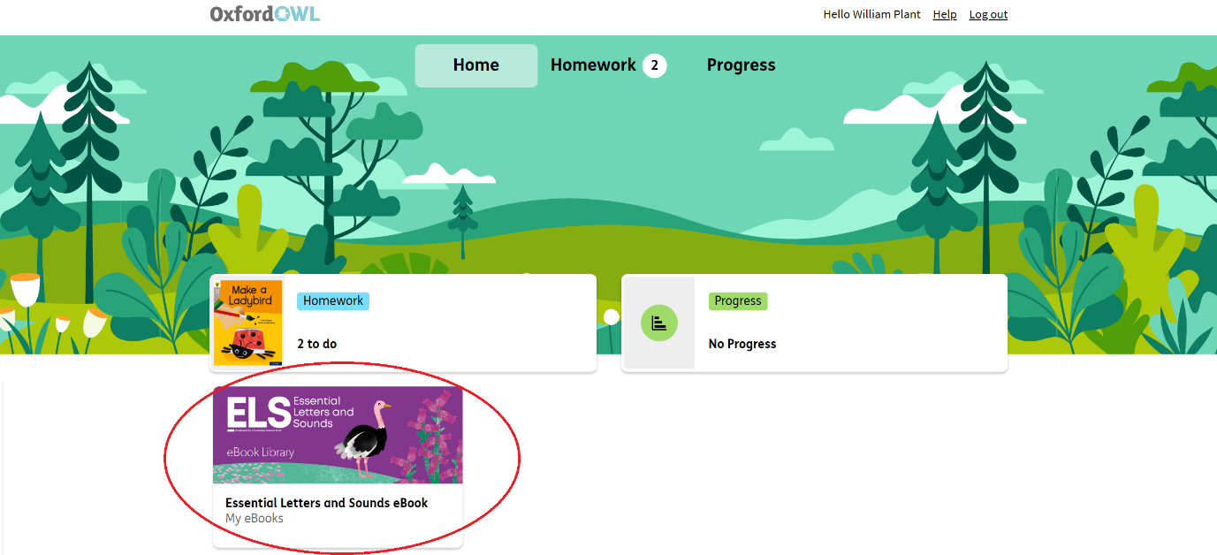
If you need further support using the eBook Library, please visit the Student Support page
Yours sincerely,
[Teacher name]

